Hyperbole(Exaggeration)– Enlarge, increase, or represent something beyond normal bounds, so that it becomes ridiculous and we can see its faults

[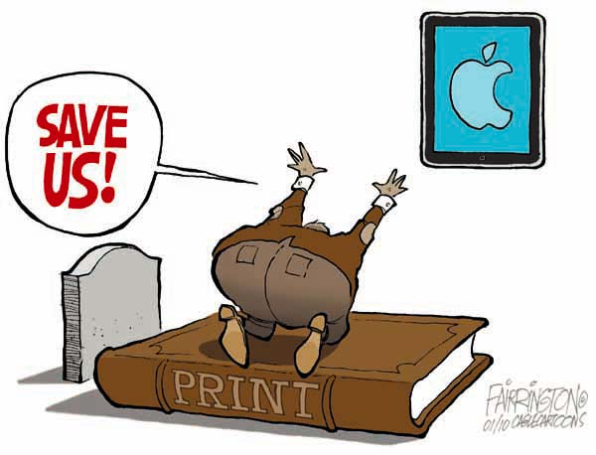](http://cagle.com/caglecards/main.asp?image=/news/iPad/images/fairrington.jpg)

Reversal **-** Present the opposite of what is normal. Flipping things on their head.

Are We Meeting The Needs Of Our Nation's Rich?



Parody - Imitate the techniques and/or style of some person, place, or thing. Typically in a humorous way.



In the Year of Darkness, 2003, the rulers of the Republican party devised the ultimate plan. They would reshape the future by changing the past election. The plan required a candidate who felt no pity. No pain. No fear. Something unstoppable. They created 'THE GOVERNATOR.'

Caricature - An exaggeration or other distortion of an individual’s prominent features or characteristics to the point of making that individual appear ridiculous.

